1. Created the Instance

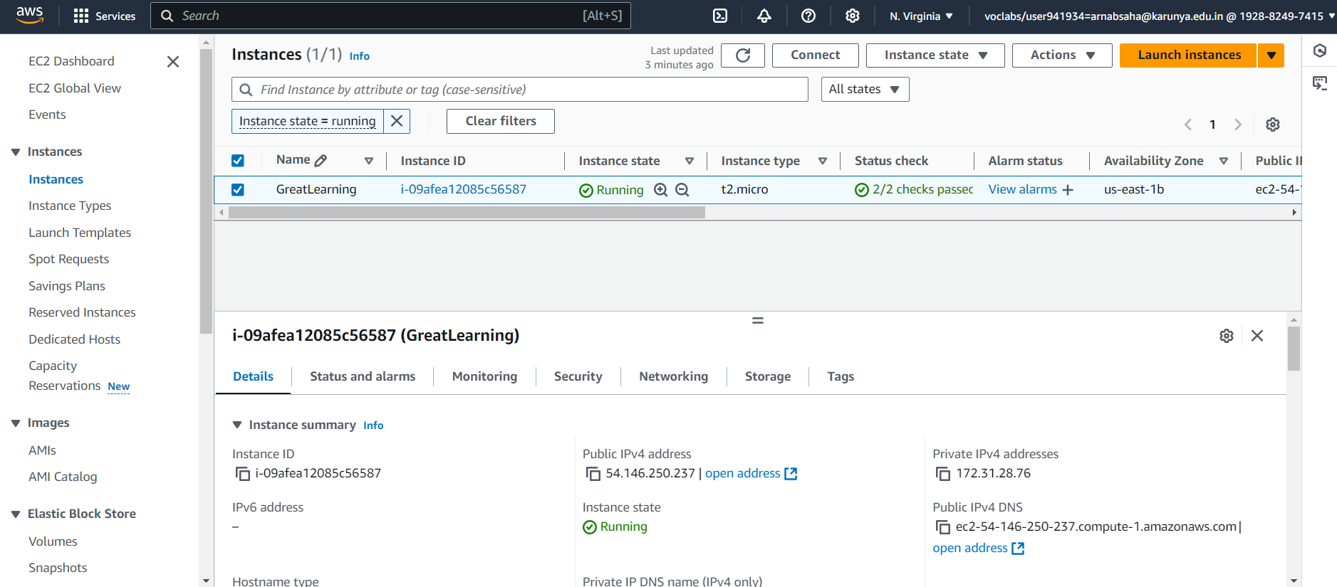

1. Created the volume of 10GB

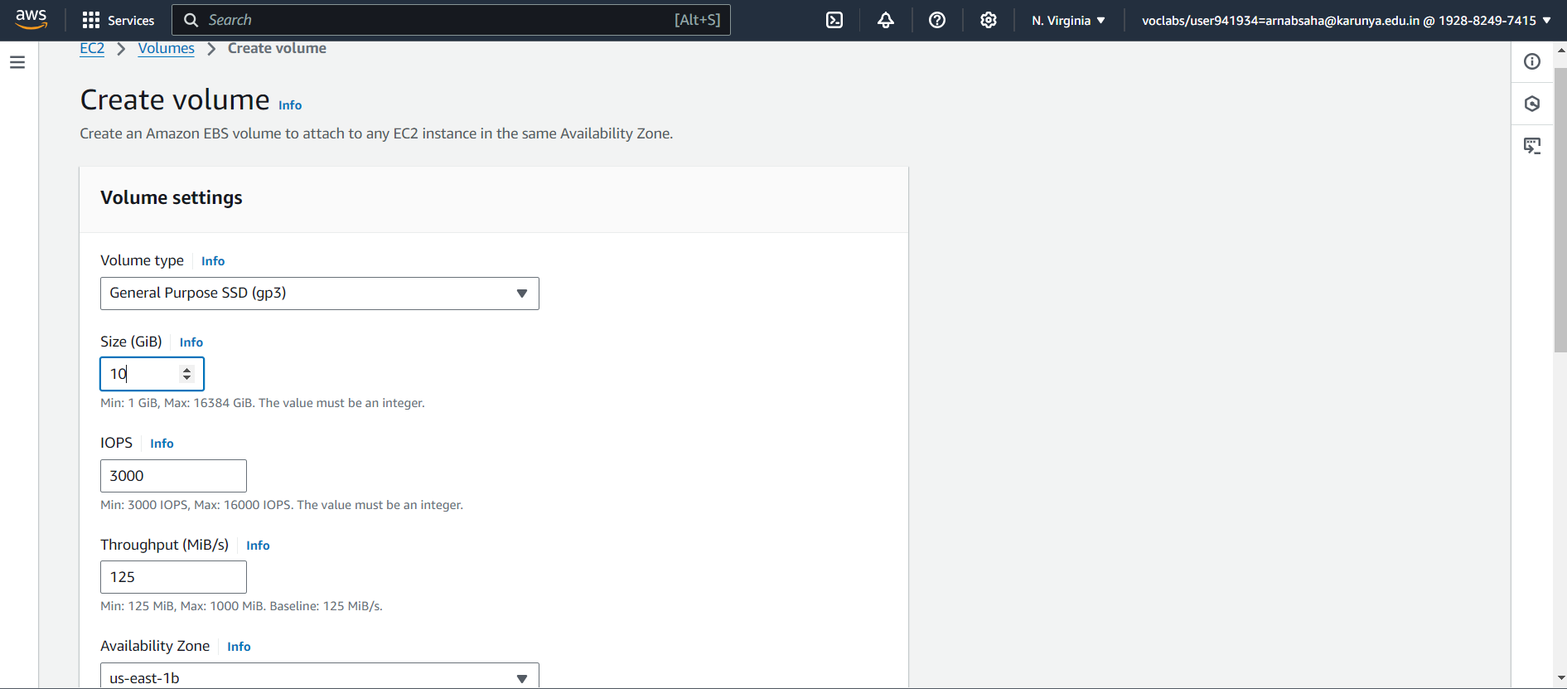

1. Attaching the 10GB volume to instance

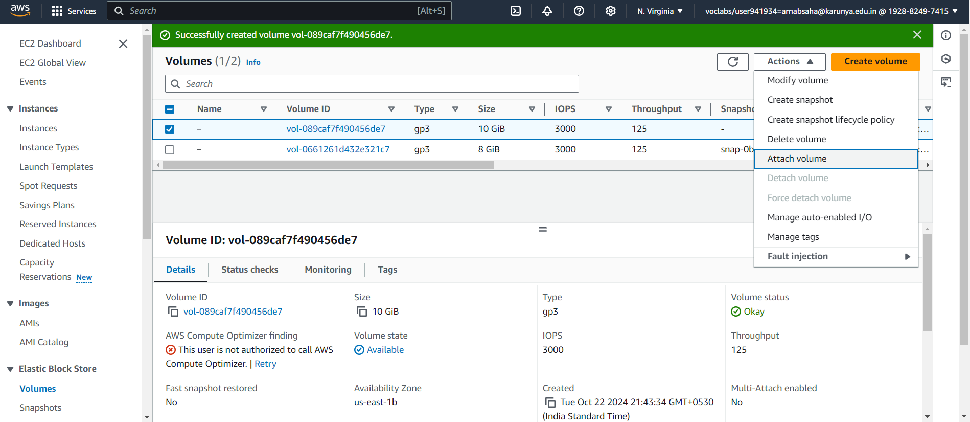

1. Attaching the instance

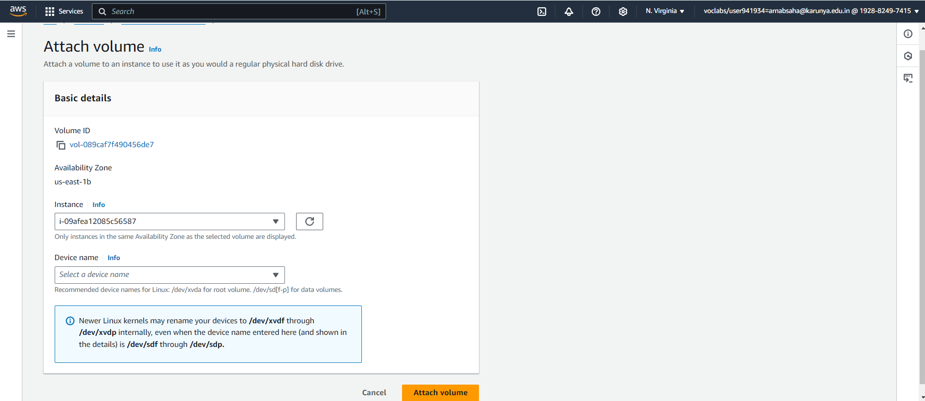

1. After attaching we can see two volumes in the instance.

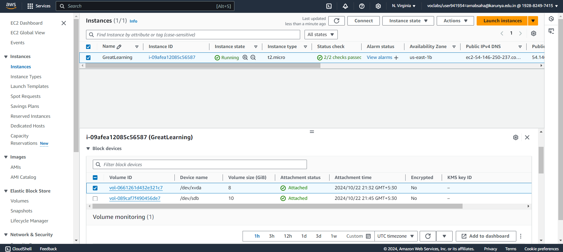

1. Connected with the instance via CLI for formatting and mounting.

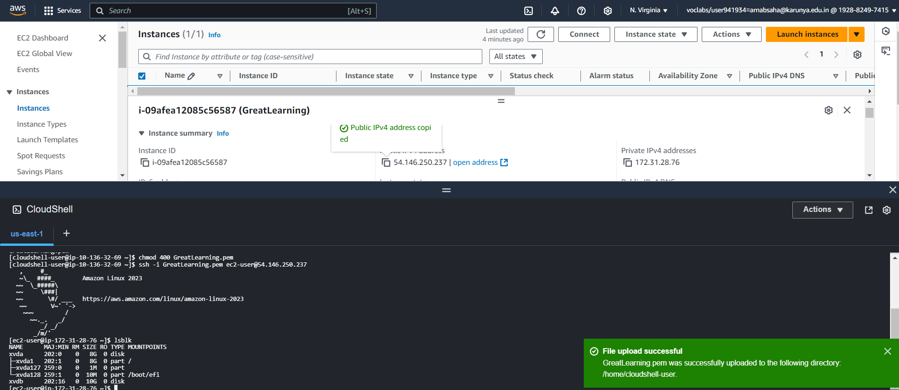

1. Mounted the volume.

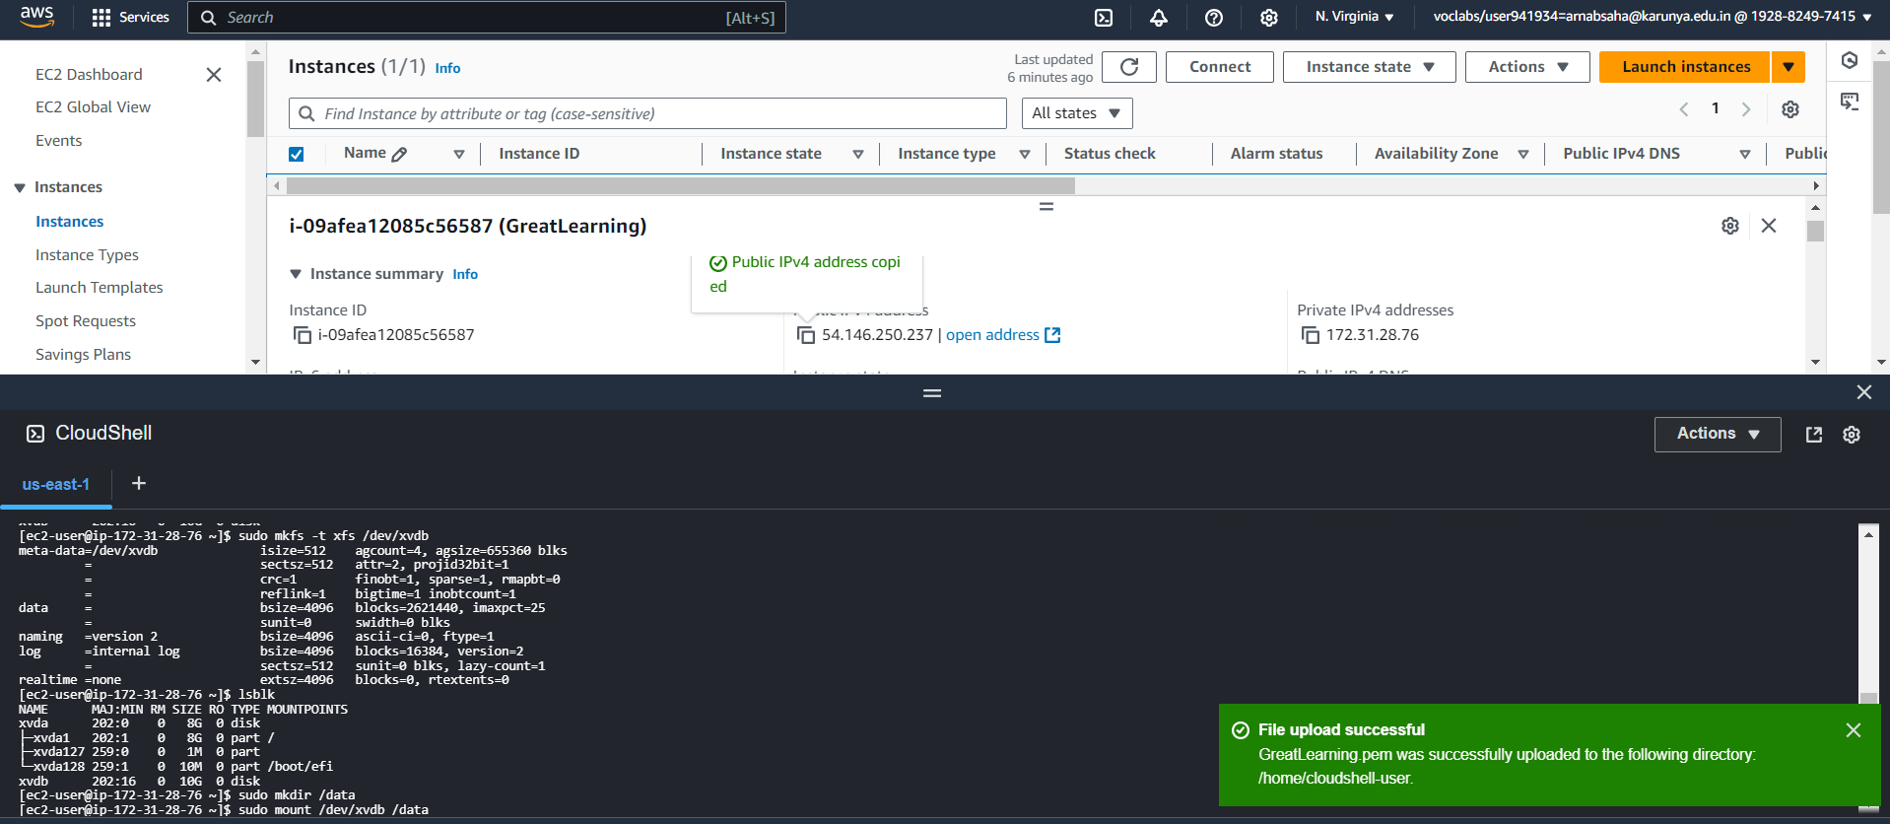

1. Entered a sample text line on a sample file.

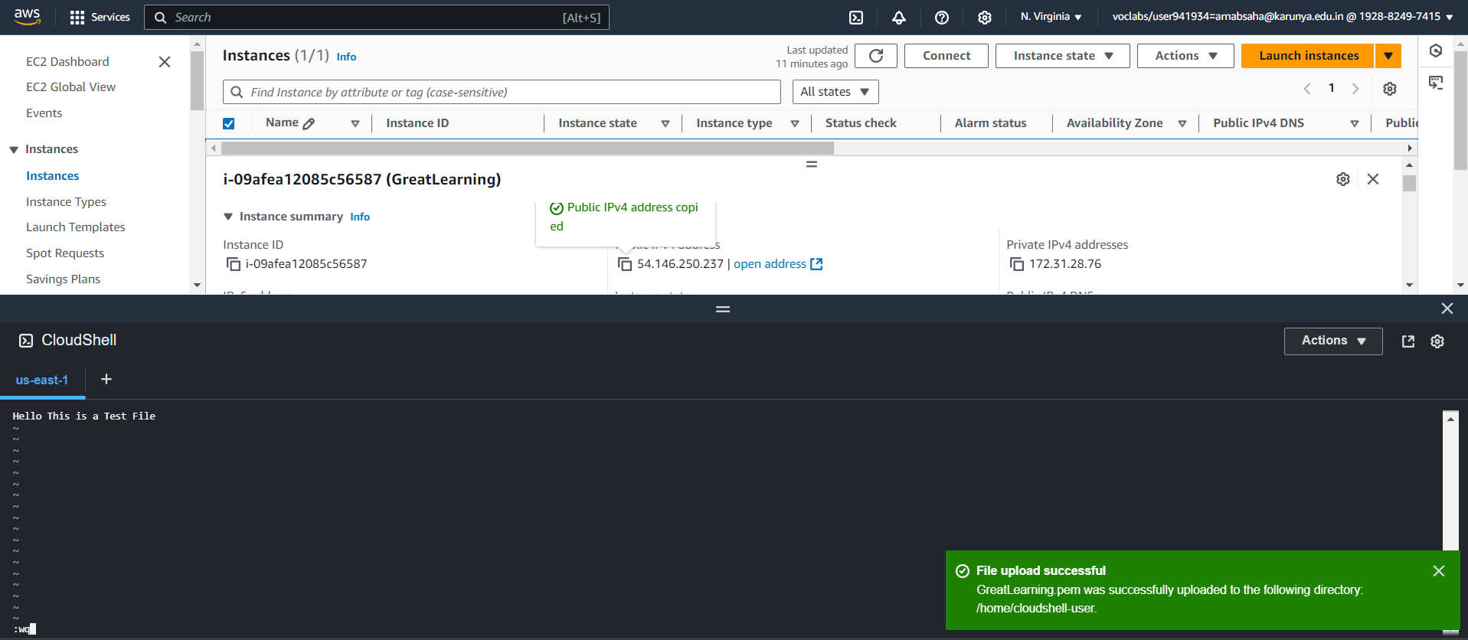

1. We can see the sample data.

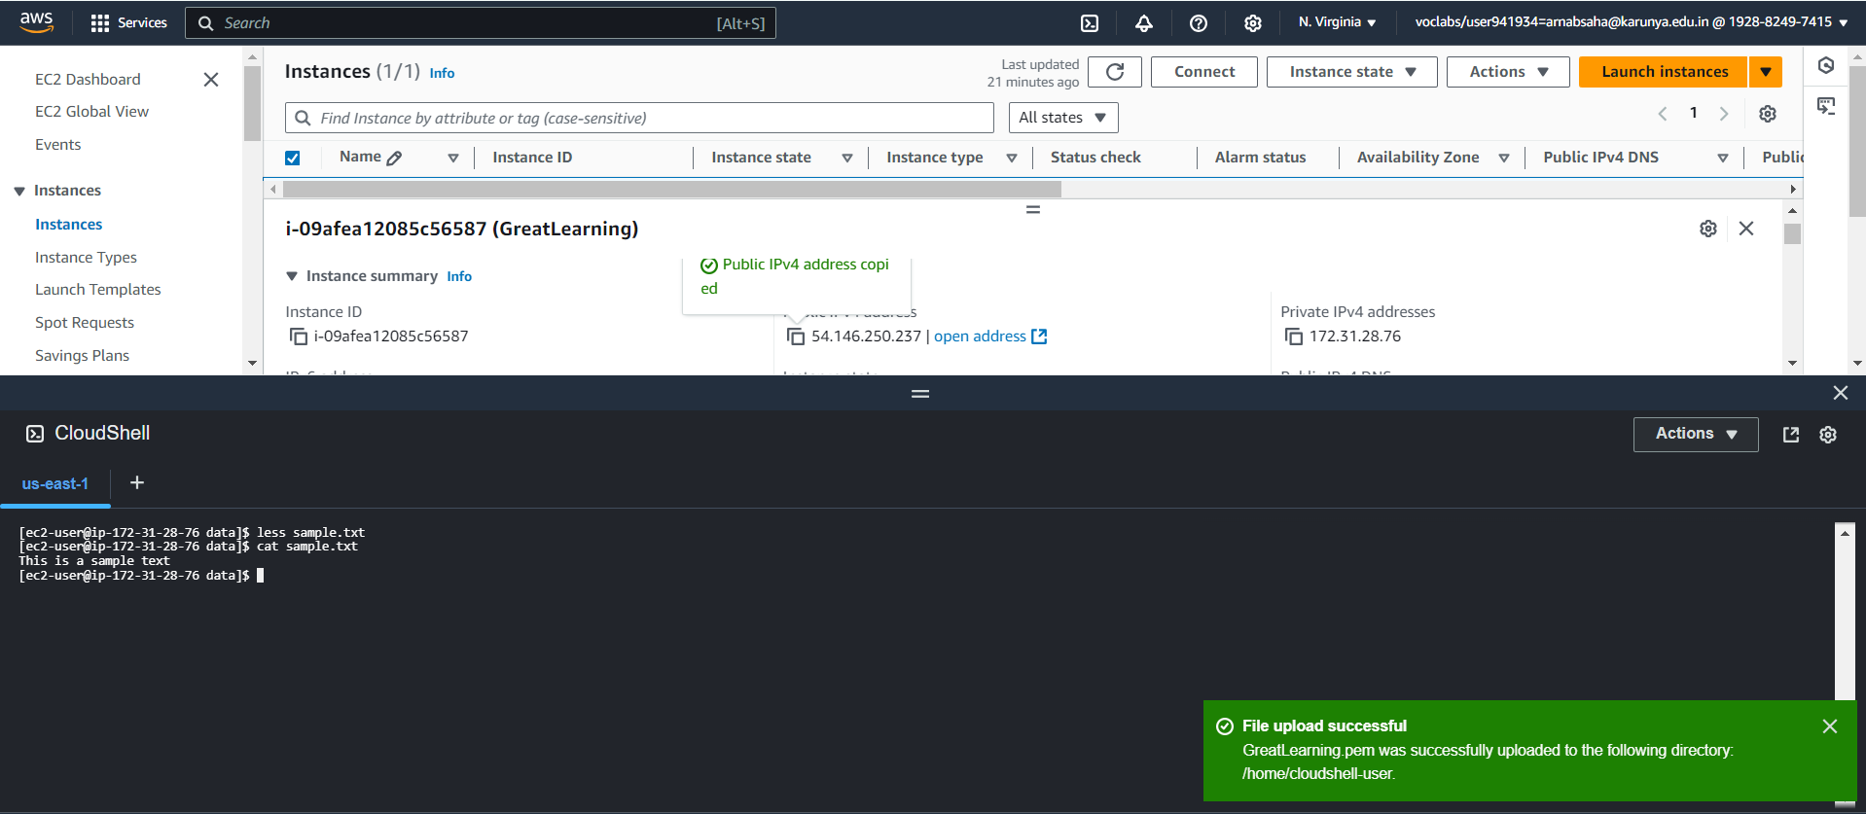

1. Unmounted the /data

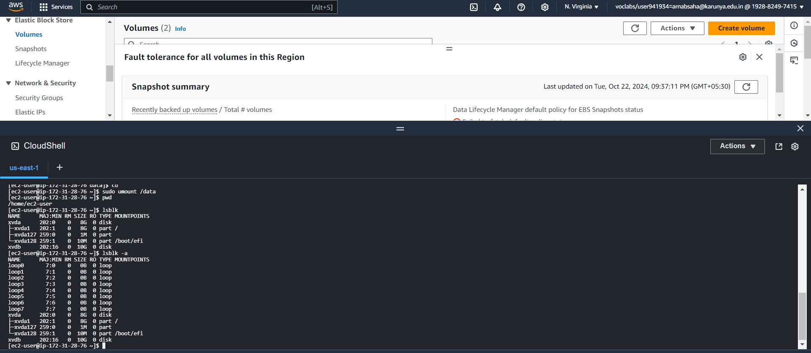

1. Detaching the volume from the instance

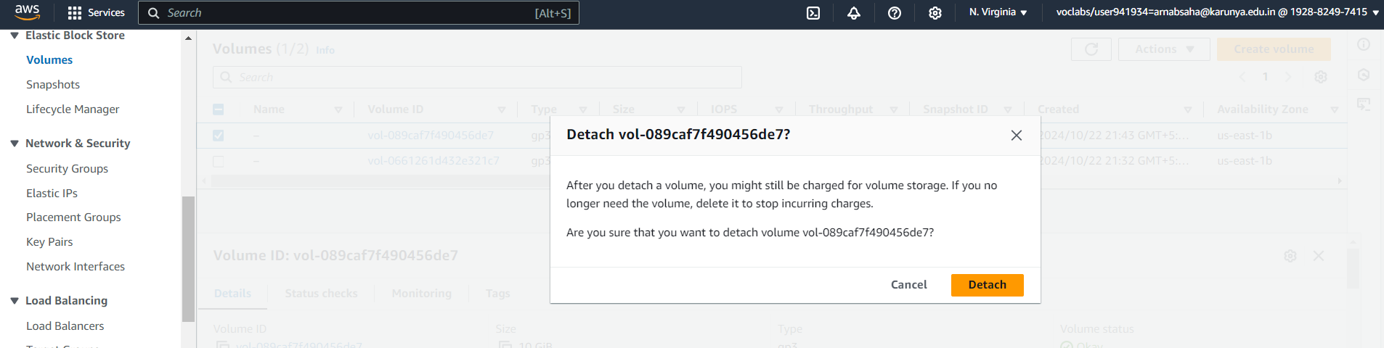

1. Taking a snapshot of the volume.

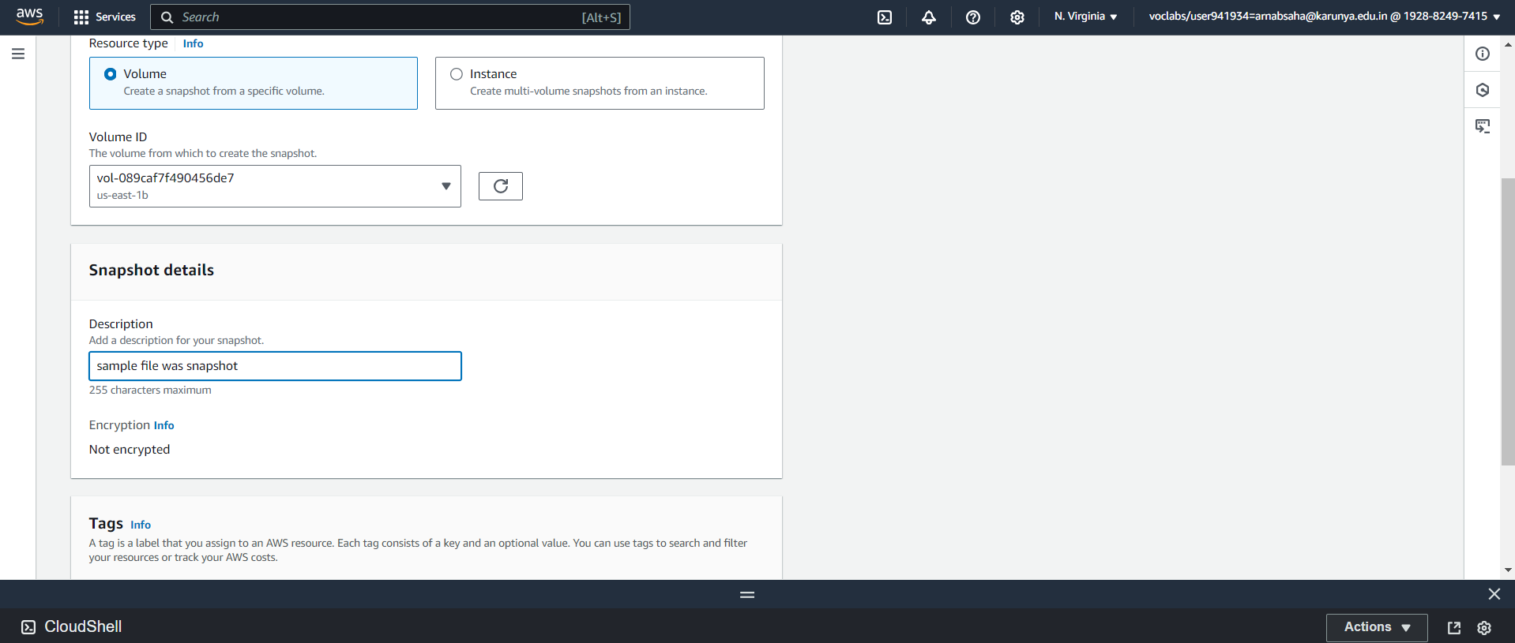

1. Attaching the snapshotted volume of 15GB to Instance

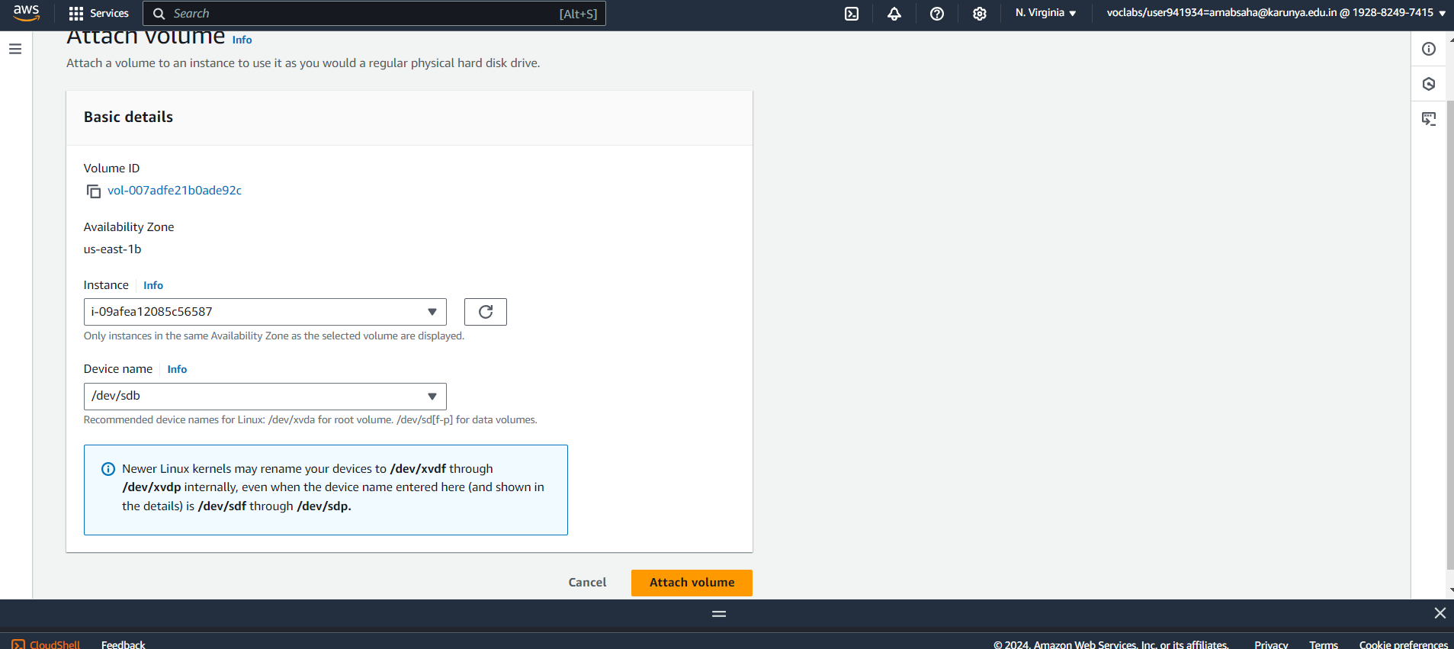

1. We mounted the /data and we can see the sample text file available on the volume

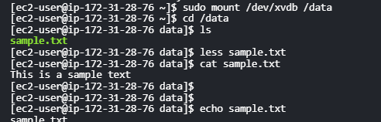

1. The Instance has 2 volumes attached with the new 15GB.

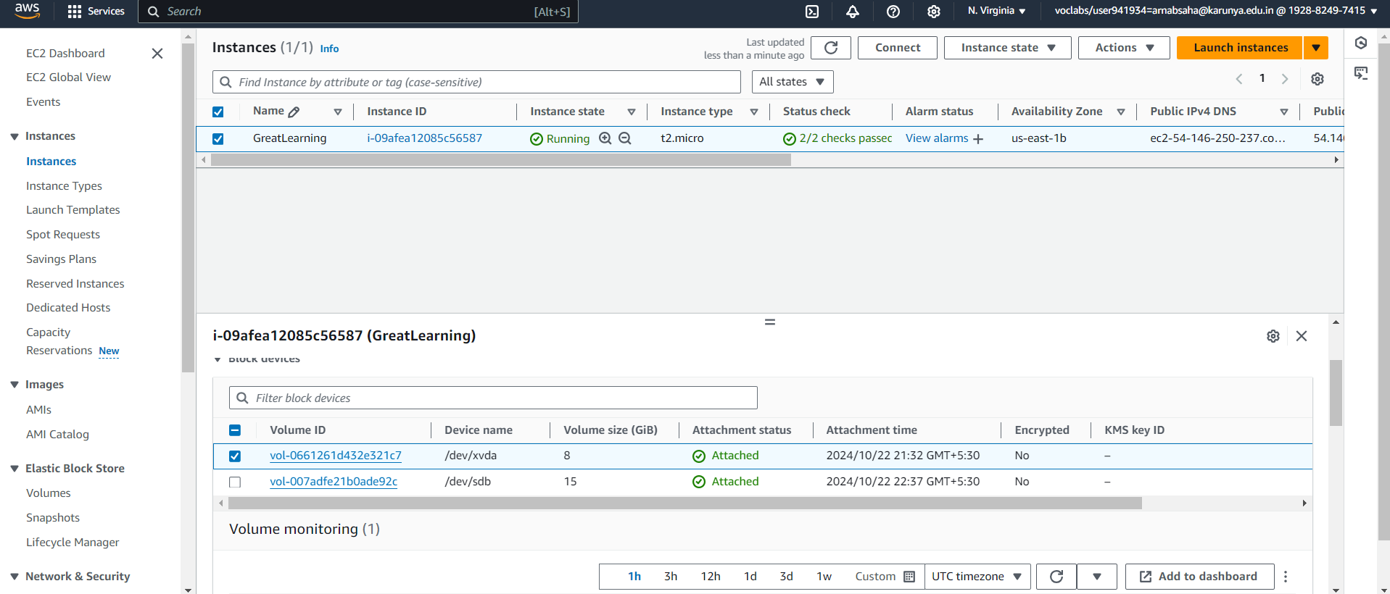

Thank You^_^